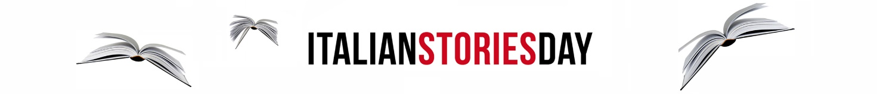

ITALIAN STORIES DAY - LE PRODUZIONI STATUNITENSI PRESENTI

Amc Networks
Annapurna Pictures
Anonymous Content
Caa
Constantin Film
Disney +
Endeavor Content
Federation Entertainment
Filmnation
Media Strategies International
Nbc Universal Television
Paradigm Agency
Picture Perfect Federation
Skybound Entertainment
Stx Entertainment
Sonar Entertainment
Sony Pictures Television
Veritas Entertainment Group

LE PRODUZIONI ITALIANE

11 Marzo Film
Alexandra Cinematografica
Compagnia Leone Cinematografica
Edi - Goon Films
Fabula Pictures
Jean Vigo Italia
Lux Vide
Minerva Pictures Group
Publispei

